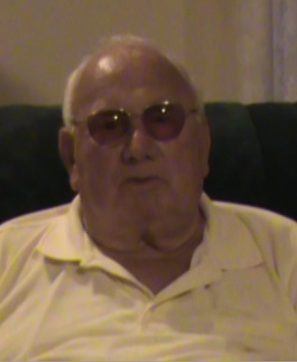
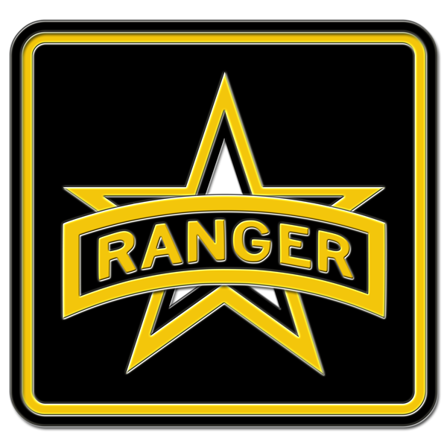
BOB SALES
U.S. ARMY RANGER
&
D-DAY VETERAN

A LONG ROAD TO TRAINING
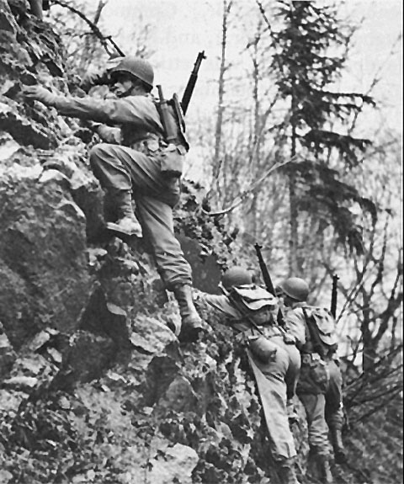
“In December of 1940 I enlisted in national guard, I was 15, I was inducted into service in 1941. I went to maryland on febuary the 20th and trained here for a while. I was in South Hill Virginia when I heard about Pearl Harbor, this was war”. “We were sent off as soon as we got back to the base, We spent months away from the fort, Sales then spent time in Florida. After traveling to both New york and New Jersey me and the group was told to pack their bags, we were being transported overseas aboard the Queen Mary.” “The next morning I was in England, I trained in general combat, hand to hand, I went swimming as well, yet I did not get into fitness until later. Sgt. Wright was a good friend to me, he ended up being killed in front of me. Capt. Zappocutca from Philadelphia, he was in the regular army but tough. I was a part of the 25 Ranger Battalion, I trained with British commandos. I partook in very rigorous training, including 7 mile hikes with all their gear and a 15 mile hike I survived off of British Rations, not much compared to US rations. This training helped with survival.”
THE LONGEST DAY
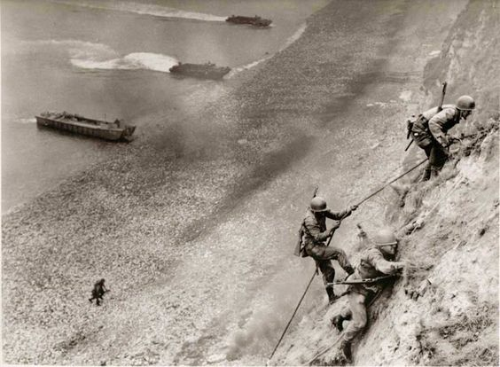
“We landed about 7:00 am, we found most of the dead and wounded on the beach, when we got out of the landing craft, I was the radio operatior. The boats formed a line Abreast formation they got close and the captain told me, What can you see, I said I saw fire and smoke, the coxswian said he could not go any further dropped the raft, and the captian was killed my buddy got hit as well and he was killed as well. When I got off the boat I sank to the bottom of the sea due to the gear I was carrying. I ditched the radio and shot back up out of the water then I swam to the captain but when I arrived the blood was bubbling. I kept crawling until he found a log a buddy helped me and soon I made it to the beach. That's where Sgt. Wright saved my life as I was walking towards him they got hit from rocks from mortars I saw the battalion doctor soon enter the battle instantly killed by Machine guns. After two hours I made it to the sea wall then I found some other men without guns, we did not know if our allies rolling onto the beach were alive. It was total total chaos, first waves were almost cannon fodder they never had a chance.”
POST NORMANDY
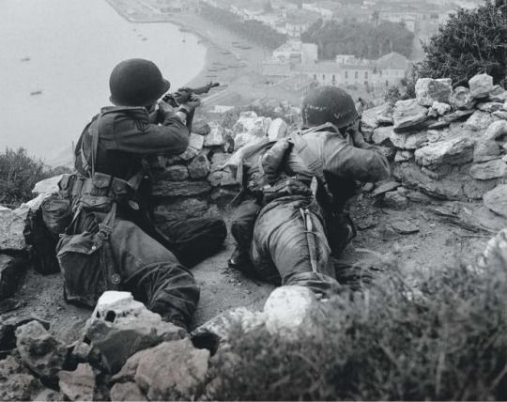
“I went back to the ship, My firend Max Smith lost his eye at Normandy, once the doctor arrived I demanded that I return to the front, I was cleared and was told to catch a boat shuffling in Wounded, so I grabed his gear and waited. Even with a ship going to england I chose to fight, I stayed for two days until I reunited with B company, they were out of everything they need to regroup and resupply, we stayed there two-three days and then we were called back to front, they had travel losses, a lot of small towns on the way throught france, towns totally destroyed. When I returned the town of St. Lowe was rebuilt we fought for 44 days, then moved onto the next town, 2nd, 8th and 29th divisions were having trouble there, then we moved on to another town. A U-boat base, this town was tough, soldiers were told to fight to the death, took several months, 40,000 germans surrendered after the battle”.

WAR MEMORIAL
“The D-Day Memorial, it's the greatest thing in the world, It was not until about 20th aniversery did people talk about their experince, In 1990 I held a memorial for Sgt. Wright, B company. I built a memorial with help from his company. June 6th 1990 I held a memorial to Harold Bumgardner in Jacksonville, FL. I am one of few living men who came out of Lynchburg 1 or 2 are still living after 67 years would I do it again?, I doubt it.”
